Home page

Option: research & clinical

Introduction to website



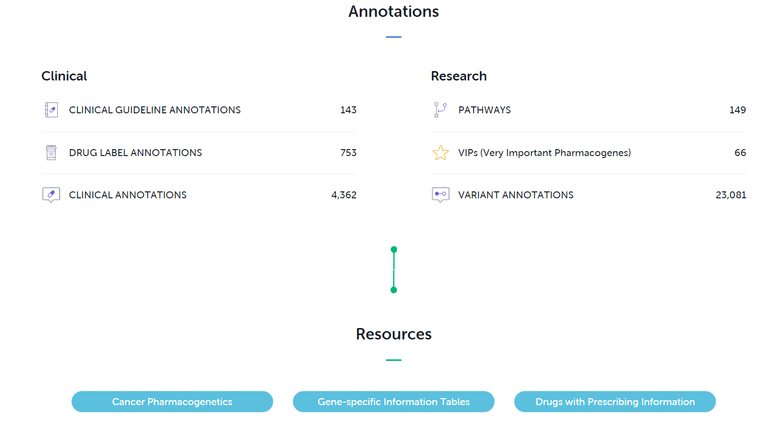

Detailed introduction to annotation.(hyperlink)

Search for drug/variant/……(optional)

Research:

According to pathways matching, rank from the most matching to the last. Show the VIPs(Very Important Pharmacogenes) or haplotype and their specific Variant and annotations.

|  |  |  |  |
| --- | --- | --- | --- |
| Rank | Pathways | VIPs(Very Important Pharmacogenes)  or haplotype | Variant and its annotations |
| 1 | Pathway1 | Gene1 | Indel1 |
| Indel2 |
| Haplotype1 |  |
| 2 | Pathway2 |  |  |
|  |  |

Clinical:

Rank in drug-variant matching (variant number). If find one drug, search for drugs which treat the similar disease and list. If variant number is the same, rank in Strength of Evidence rate. Then list the annotations for drugs, VIPs(Very Important Pharmacogenes) or haplotype and their specific Variant, annotations and Strength of Evidence rate.

Choose approval agency for drug labels containing pharmacogenetic information

Or other search criteria.



|  |  |  |  |  |  |
| --- | --- | --- | --- | --- | --- |
| Rank or disease | Drugs | VIPs(Very Important Pharmacogenes)  or haplotype | Variant and its annotations | Drug label annotations | Strength of Evidence rate |
| 1.1 | Drug1 | Gene1 | Indel1 |  |  |
| Indel2 |  |  |
| Haplotype1 |  |  |  |
| 1.2 | Drug2 | Gene1 | Indel1 |  |  |
| Indel2 |  |  |
| 2 | Drug3 | Gene2 |  |  |  |